Refer to code:

004-app.js

004-friends.ejs



* Use body parser to get form data from the request body.

- req.body is an object that contains all the data comes from the request.

Remember: for get request, the data is at queryString; for post request, the data is at request.body

- when you use a form to post a request, all the form's data comes inside the request's body

- BUT EXPRESS by default does not create req.body for us!!! you need to install the body-parser package:

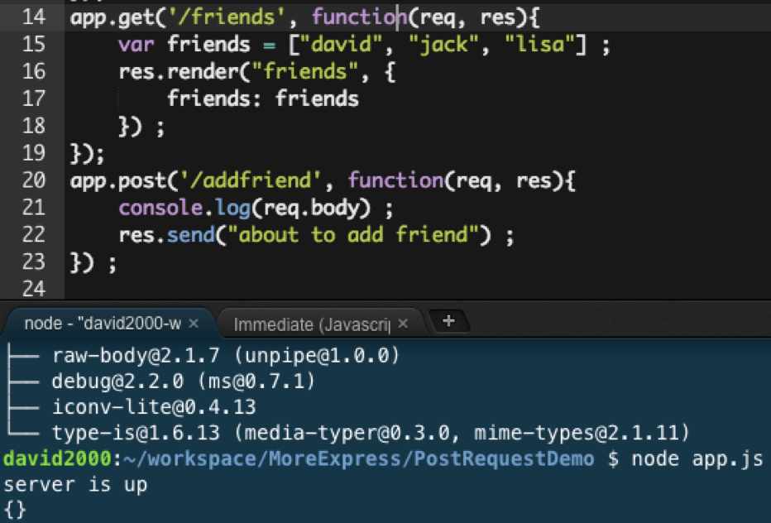

in order to be able to parser the req.body, have to let the app use the bodyParser





now the req.body will be like this:





the new friend is added to the list and because we used the res.redirect(‘/friends’), we can see the updated friend list.



# Post Requests!!!!

- Note: get request can be visited in the url, while POST request can only be visited through form or postman

* Write post routes, and test them with Postman

- app.post('/url', function(req, res){var somevar = req.body.name}): its only triggered by POST request

- remember you only use post route once you want to send something to database

* Use a form to send a post request

- <input name="varname"> : here the varname along with its value will be put in the POST request body(very useful for server end to get it out)

// set up

var express = require("express");

var app = express();

var bodyParser = require("body-parser") ;

app.use(bodyParser.urlencoded({extended:true})) ;

app.use(express.static("public"));

app.set("view engine", "ejs") ;

- res.redirect('url')